The Facebook hack I’m trying to conquer my addiction

The Age, MARCH 28 2017

Caitlin Fitzsimmons

I am trying something radical to break my addiction to Facebook. It's hard to write this because I don't want my friends to think I'm not interested in them, when the opposite is true: I'm too interested.

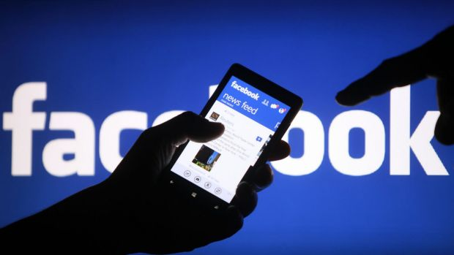

I'm spending too much time on social media in general and Facebook in particular and I'm desperate for a change. So here's my big confession: I'm hacking Facebook to make it really boring, by unfollowing everything and everyone.

I started a few days ago and it's working already. Now when I mindlessly open Facebook whether on phone or desktop computer, I mostly get the message "no posts to show" and a button to click to "find friends". Sometimes I'll get a sponsored post or an invitation to advertise one of my posts. Whenever a new post pops up from one of my friends, I'll immediately unfollow.

My news feed is now a wasteland, and it's fabulous. It's been less than a week but I'm already going to Facebook less often and spending less time when I do. It makes sense, because when Facebook introduced the news feed in 2006, it instantly increased what the marketers call "stickiness" or the amount of time people spend on the site. I'm reverse-engineering it to reduce the appeal.

I haven't unfriended anyone. Some time on the weekend I can make the conscious effort to think of someone and look up their profile. It'll be like Facebook way back in the old days – before most of us even joined – when you had to wander through the site like a virtual treasure hunt.
I might use the almost-obsolete telephone function on my smartphone and call up a friend I can't see in real life. Best of all, when I meet up with friends, we'll have something to talk about because we won't already know each other's news.

I know some people who don't use social media at all and that's all very well, but I don't feel that's realistic for me. I use social media for work, and it's important for me to engage with an audience, and keep current with trends and touchstones for discussion.

There's also the fact that so much of my social life is arranged through Facebook. I don't want to be that person who always needs a separate invitation because I can't be invited to the Facebook event. There's only room for one social media refusenik in a family, and my husband has already bagsed that. This way, people can still tag me and invite me to events. I can visit Facebook rather than living there.

Interestingly all personality types are susceptible to social media addiction. Studies suggest extraverts use social media for social enhancement, while introverts use it for social compensation. Both reasons lead to greater usage and can lead to addiction.
On the one hand, neurotics and narcissists use social media frequently, on the other hand people who score highly for "agreeableness" and conscientiousness also use it more than others.

Social media addiction can be as serious as any other addiction. I'm not like the 24-year-old woman who used Facebook for five hours a day and lost her job because she continuously checked social media instead of working. I can ignore social media completely when I'm out of my ordinary environment – I locked my phone in the car when I went camping in January, and I deleted the apps and didn't use the mobile web versions when I went skiing last August.

It's when I'm at home and going to work each day that I find the habit too strong to break.
Modern browsers are smart, they know your habits and I only have to type 'f' into the navigation bar and I'm on Facebook before you know it. I can only really break the habit if there's nothing to see when I'm there.

I may not be a full-blown addict, but it's borderline. I don't need a professional diagnosis to tell me that my compulsion to check social media is a problem for me. I use it to procrastinate when I should be working, justifying it as professional outreach, research and brand building. Then I work overtime to compensate. It cuts into my personal time, when I should be spending time with friends and family, or going to bed at a reasonable time. And it undermines my authority and credibility as a parent because I police my kids' screen time and then over-indulge myself. We all know "do as I say, not as I do" doesn't work.

I've tried setting rules but I don't follow them. I've tried deleting the apps from my phone, but I've found the mobile sites are almost as good. So I'm trialling this method, which actually came from one of my creative mentors, writer and online entrepreneur Christine Gilbert. She swears by it.

I might find it's too extreme and eventually settle on a middle way, but right now I'm relishing the scorched earth approach. Forget self control or going cold turkey, this is the social media equivalent of the methadone program.

Caitlin Fitzsimmons is the editor of Money and a regular columnist. You can find her on Facebook or Twitter – maybe.

